- Q1) Create a directory named CS361 under your home directory. Then create directories named lab1 lab2 lab3 ... inside the CS361 directory. Also create a directory named test inside the directory lab2. Write all the commands.(assuming the current directory is home directory)
  - mkdir CS361
  - mkdir CS361/lab1
  - mkdir CS361/lab2
  - mkdir CS361/lab3
  - mkdir CS361/lab2/test
- Q2) Go to the CS361 directory and list all the directory names starting with l. Write the commands.
  - cd /home/CS361 or cd CS361
  - ls l*
- Q3) Move a file from directory lab2 to the directory lab1 and delete the directory lab3.
  - cat > lab2/file1
  - mv lab2/file1 lab1
  - rmdir lab3 (don't use rm )
- Q4) Displaying the contents of a file on the screen.
  - cat lab2/file1
- Q5) Make a copy of the directory CS361 in the same level and name it as CopyOfCS361. (All subdirectories and files inside should be copied.)
  - cd ..
  - cp -r CS361 CopyOfCS361
- Q6) Write a shell script that takes a keyword as a command line argument and lists the filenames containing the keyword.
#ss
#usage:ss
echo "enter keywords to display all files starting with it\c"
read key
ls key*

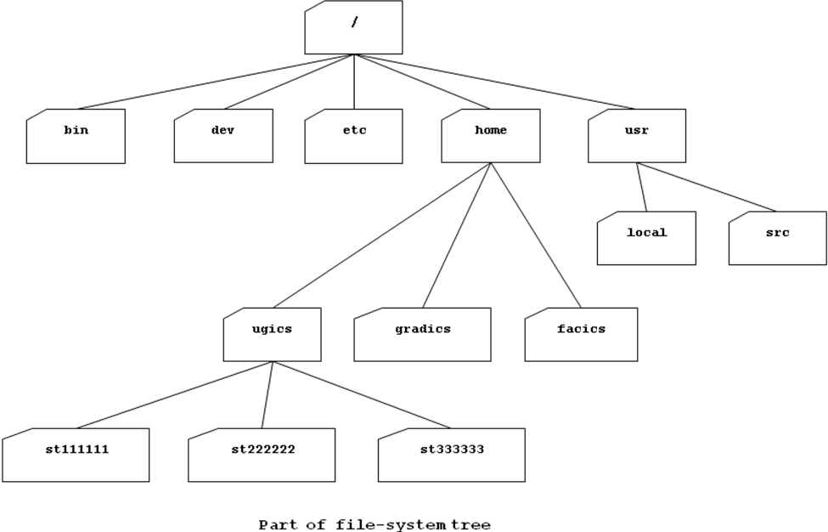
- Q7) Use the above diagram and assume that your current working directory (your current position in the file system) is ugics:
- A file named “salam.txt” is placed inside the directory “st111111”.
The absolute (full) name is: /home/ugics/st111111/salam.txt
The relative name is:
st111111/salam.txt OR ./st111111/salam.txt
- A directory named “ahmed” is placed inside the directory “gradics”.
The absolute (full) name is: /home/gradics/ahmed
The relative name is: ../gradics/ahmed
- A file named “csh” is placed inside the directory “bin”.
The absolute (full) name is: /bin/csh
The relative name is: ../../bin/csh
- A directory named “st123456” is placed inside the directory “ugics”.
The absolute (full) name is: /home/ugics/st123456
The relative name is: st123456 OR ./st123456
- Make a subdirectory called cs361 in your current working directory .
  - mkdir cs361

- Make another directory inside the cs361 directory called “LabCS361” then make “LabCS361” your current working directory.
  - mkdir cs361/LabCS361
  - cd cs361/LabCS361
- Now type the command:
cd ..
followed by:
ls
- In which directory you are located now?
  - cs361

