THE EQUILIBRIUM TEMPERATURES IN THE HARAM AREA, MAKKAH DURING RAMADAN 1429 H AND THEIR IMPACT ON THE UMRA PILGRIMS COMFORT II

OMAR M.Y. ANBAR
Department of Meteorology, Faculty of Meteorology, Environment and Arid Land Agriculture, King Abdulaziz University, Jeddah, Saudi Arabia

Abstract

The calculation of equilibrium temperature was carried out in Makkah using a computer program called Human Energy Balance Factor and the data taken from the station 1 located in the Haram area neighbors Ajyad Hospital from the eastern side of the Holy Haram Almakky gates between 15th to 28th of Ramadan 1429H (16th – 29 September 2008). On 17th Ramadan 1429H(18th September 2008), the extreme value of the equilibrium temperature $T_{\text{Eq}}$ reached 38°C leading to the feeling of discomfort, and thermal stress with an increase in wind speed of 3.5 and 3.75 m/s between 1000 and 1100 hours with high humidity. The peak value reached 25 millibars at 1200 hours when the equilibrium temperature was at a peak value as well. The 25th Ramadan 1429H was a day with a distinctive appearance or extraordinary of the curve [the line winding (zigzag) like that occurred on 26th Ramadan, 1430, (Anbar, 2010)]. This guides to the irregularity presence of people (crowds came in and went out the Grand Mosque in Makkah). The rise in equilibrium temperature on this day has nothing to do with moisture, because this day was drier than other days. It was very dry in early morning between 0600 and 0900 hours with a value of 8 millibars. Convergence of the extreme values of the equilibrium temperature $T_{\text{Eq}}$ with the temperature of air on 25 Ramadan 1429 reaching almost a maximum value of 38°C at 12 hours was found. There was also an extreme value of $T_{\text{Eq}}$~ 29°C at 1800 hours. The reason here also might be severe overcrowding in these days and nights in particular (the last ten days of Ramadan).
On 28th Ramadan 1429 (29th September 2008), the maximum equilibrium temperature exceeded air temperature at midday by up to 6°C with high humidity with of an average of 25 millibars throughout the day. The 6°C difference was never found in any given day in Ramadan, as well as an increase in equilibrium temperature at the highest value in the morning on the same day reaching 28˚C. It is the highest among all the previous days. These results confirm that congestion on this day (last days of Ramadan-Umrah) raised the humidity which reached a water vapour pressure of 25 millibars, as we have seen, and also increased the value of the equilibrium temperature that makes a person really suffer thermal stress.

1. Introduction

Chenvidyakarn (2007), reported that achieving thermal comfort through passive means in hot humid climates is not always easy. Characterised by relatively high temperatures and high humidities, these climates usually require both cooling and dehumidification. These difficulties lead to many buildings relying completely on air-conditioning. Nevertheless, a
range of passive design techniques may be employed to help minimise or avoid this reliance. In hot humid climates where the humidity level is often above the comfortable limit, dehumidification is an important part of thermal comfort strategy. Typically, dehumidification in these climates is accomplished by mechanical air-conditioning. However, this can be highly energy consuming, as often to reduce moisture to a required level, humid intake air has to be cooled to a temperature below that required for thermal comfort. Chenvidyakarn (2007) added that in hot climates, a significant amount of energy can be saved if cooling needs can be minimized. In general, to achieve this, solar and conductive heat gains should be contained, and natural ventilation promoted for cooling and humidity removal. Some of the key strategies for minimizing cooling needs involve appropriate orientation and spatial organization, shading, and appropriate use of materials, colours, textures and vegetation. He also pointed out that thermal comfort is complex and partly subjective. It depends on many factors, of which air temperature, humidity, air movement, thermal radiation, the metabolic rate and the level of clothing are fundamental. The impacts of these factors on the thermal balance of the human body irrespective of adaptation to the local climate form the basis of theoretical comfort models/standards, such as Fanger’s PMV.
Tanabe et al (1994), studied nude thermal manikin in sitting posture exposed in a climatic chamber to 3 operative temperatures. Heat losses from the whole body were 91 ${\text{Wm}}^{−2}$ at an operative temperature of 19°C, 64.5 ${\text{Wm}}^{−2}$ at 25°C and 37.7${\text{Wm}}^{−2}$ at ͠ 30°C. Heat losses at the feet and hands were slightly greater than those at other parts. The combined heat transfer coefficient for the nude and sitting manikin wasn't affected by the exposure temperature. The mean of the combined heat transfer coefficients for the whole body in the nude was 8${\text{Wm}}^{−2}\text{.}C^{−1}$ . When the radiative heat transfer coefficient for the human body was assumed to be 4.7${\text{Wm}}^{−2}\text{.}C^{−1}$, the convective heat transfer coefficient $h_{c}$was estimated as 3.2 ${\text{Wm}}^{−2}\text{.}C^{−1}$. They added also that, the manikin was exposed in the climatic chamber in sitting and standing postures wih clothing. Heat losses from the whole body were 48 ${\text{Wm}}^{−2}$ for sitting posture and 45.3${\text{Wm}}^{−2}$ for standing posture. Total thermal resistance for the whole body was 0.189$m^{2\text{.}}\text{.}C/W$(1.22 clo) for sitting posture and 0.202$m^{2\text{.}}\text{.}C/W$(1.32 clo) for standing posture. Basic clothing insulation value of testing ensemble in sitting posture was 0.55 clo.

2. Methodology

A model called Human Energy Balance Factor as a computer program written by using visual basic (Microsoft Access) was applied for all calculations in Anbar (2010). the Equilibrium Temperatures $T_{\text{Eq}}$were computed as:

$T_{\text{Eq}}=T_{s}+h_{c}^{−1}(M_{n}+R−E)$ (1)
which is derived from the equation mentioned in (Anbar, 2010):

(2) $M_{n}+R+h_{c}(T_{s}−T_{a})−E=0$
where $M_{n}$is the metabolic heat production , R, C and E are the radiative, convective and evaporative heat losses, respectively as explained in Anbar (2010). The Equilibrium Temperatures $T_{\text{Eq}}$ were calculated using the model of calculation of human energy balance factor for an adult man wearing light Haj ‘Ihram’ and ‘Thowb’ (light wear) clothes, Ihram means that one third of his body is unclothed at different walking speeds in km/h, in a cloth type insulation of 0.5 clo and with metabolic heat of 233 at walking speeds of 4 km/h because Makkah is mountainous area.
The second item in the left hand side of Eq. 2 was written as we have seen in (Anbar (2010) as;
(3)
where $R_{s}$and $R_{L}$are net short wave radiation and net thermal long wave radiation. The absorbitivity is $a$, $R_{\text{si}}$,$L_{L}$is the incident short and long wave radiation respectively, $σ$is the Stefan-Boltzman constant and $T_{s}$ is the surface temperature of clothed man. Blazejczyk, ( 2001) pointed that to assess thermal conditions we should consider not only physical parameters of air but also physiological response of human organism. Its intensity and heat state of man depend on the full complex of atmospheric stimuli: temperature, humidity, solar and thermal radiation, air movement, cloudiness (Fig. 1).
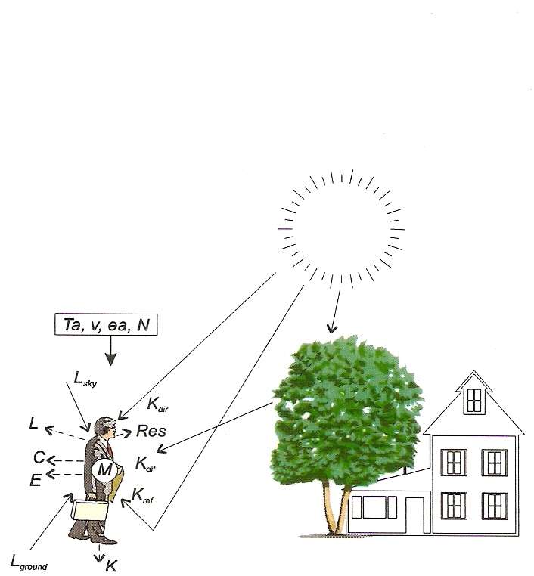
Fig. 1. Man in a complex thermal environment Ta - air temperature, ea – vapour pressure, N - cloudiness, v – wind speed, Solar radiation: Kglob - global, Kdir -direct, Kdif - diffuse, Kref - reflected, Thermal radiation: Lground - ground, Lsky - sky, Heat fluxes: M – metabolism, C - convection, E - evaporation, L - long-wave radiation, Res - respiration, K – conduction (after Blazejczyk, 2001).

Thermal insulation of skin and clothing is I_{c} and the thermal insulation of air is I_{a}. For a naked man, the thermal insulation (I_{a} =1/$h_{c}$), of boundary layer of air around his body (Cena and Clarke, 1981).
Convection C is the interchange of warm and cold fluid (Cena and Clarke, 1981). The movement of fluid which carry the heat away from the body surface driven into two mechanisms: free convection, due to density difference in the fluid associated with temperature difference; or forced convection, due to external forces such as wind. In each case the relationship between the rate of heat transfer, C, and the temperature difference between the surface and the air which drives the heat transfer. Convective heat transfer through a layer of clothing may be written as:
$C=h_{c}\left(T_{s}−T_{a}\right)$ (4)
The heat loss by the evaporation of sweat is the best physiological index of man’s environmental stress (Cena and Clarke 1981). E can be written as:
(5) $E=h_{e}\left(e_{s}−e_{a}\right)$ where h_{e} is the coefficient of convective water vapour transfer (Wm⁻² mb⁻¹), is vapour pressure of the body surface and is the environment vapour pressure..

2. Results and Discussion

Here we will review again equations used to calculate and should be also be used to approach into the surface temperature of the clothed human body T_{s}. Hendrick (1959) and Klien (1948) gave an expression for a solar heat load, on a man (the additional surface temperature of a man due to solar radiation load):

(6)
Where L is the solar heat load in kg.cal / hr, N is the thermal insulation of the air in and b is the total body surface area in m2. N can be written as follows: $N=\frac{0\text{.}\text{18}}{0\text{.}\text{16}+0\text{.}\text{19}\sqrt{0\text{.}\text{01}V}}$ (7)
where V is the wind speed. Considering only direct solar radiation (ignoring diffuse radiation), where is the direct component of solar radiation per unit area, f is the body area intercepting direct radiation, A is the albedo of human skin or clothing. The albedo is assumed to be 0.5 for an average adult body surface area of 1.7 with an average cross-sectional area of a standing adult of 0.51 . Converting SI units (${\text{Wm}}^{−2}$), the temperature change due to the direct solar heat load on a standing man becomes:
$ΔT=R_{\text{sv}}\frac{0\text{.}\text{0313}}{0\text{.}\text{16}+0\text{.}\text{19}\sqrt{0\text{.}\text{01}V}}$ (8)
The surface temperature of the clothed human body T_{s} was assumed to be a skin surface temperature of 33 °C plus ΔT (Eq.7).

An example of surface temperature of standing clothed person near the Haram area as result of solar radiation fallen on him from 7 directions, vertical incident angle of the sun $θ_{v}$ calculated from different orientations [North East ( NE), East (E), South East (SE), Souh (S), South West (SW), West (W), North West (NW) during daytime on 15th Saaban 1430H (16Ougust 2008) drawn in Fig. 2.
We do not want to confuse things with each other, but some aspects were clear after calculating radiant $T_{r}$ and an operative temperature $T_{\text{op}}$for only two days example by using the following equations:

$T_{r}={\left(\frac{L_{L}+0\text{.}\text{49}×\text{shape}×R_{\text{si}}}{σ}\right)}^{0\text{.}\text{25}}$ in (K) (9)
$h_{r}=\frac{R_{\text{eff}}}{[T_{r}−(T_{s}+\text{273})]}$ (10)
where $R_{\text{eff}}$is effective radiation field (Gagge et al 1967), $h_{r}$is thermal radiation heat transfer.
$T_{\text{op}}=\frac{(H_{r}×T_{r}+h_{c}^{−1}T_{a})}{(h_{c}^{−1}+H_{r})}$ (11)
where $h_{c}^{−1}=1\text{.}\text{88}\frac{d}{k}{\left(G_{r}P_{r}\right)}^{−0\text{.}\text{25}}$ for free convection (12) is the air resistance to convective heat transfer , d is the diameter of the human body, K ($Wm$per °C) is the thermal conductivity of the air. $G_{r}=β{\text{gd}}^{3}Δt{Δυ}^{2}$ is the Grashof number, $P_{r}=υa$ is Prandtl number, $β$ in $K^{−1}$is the coefficient of volume expansion of the air, g in $\frac{m}{s^{2}}$is the gravitational constant and a in $\frac{m^{2}}{s}$ is thermal diffusivity of the air.

Equations 8-12 included in the computer program (mentioned above). We found on both 15th and 16th Ramadan 1429H (16^{h} and 17 September 2008) that the values of radiant $T_{r}$ and operative temperatures $T_{\text{op}}$are very close to each other (figs. 3and 4).

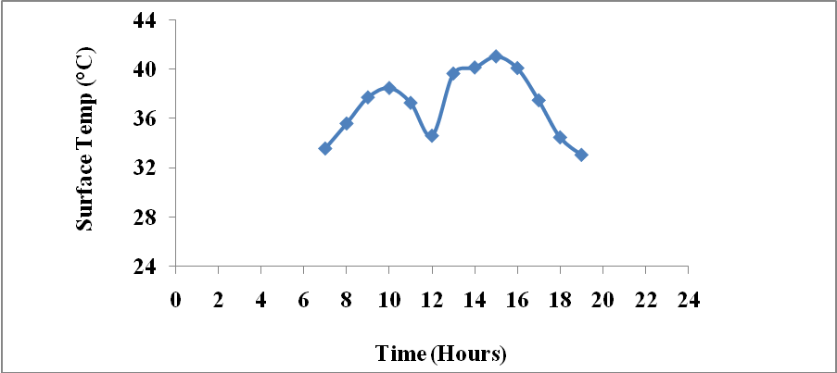

Fig. 2. Daytime surface temperature ($T_{s}$ ºC) for a clothed man on 15th Ramadan 1429H (16^{h} September 2008).

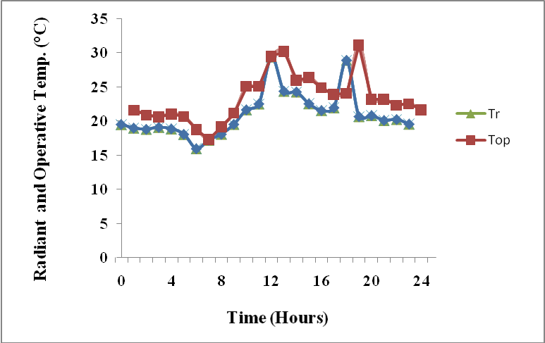
Fig. 3. Radiant $T_{r}$and operative $T_{o}$temperature (ºC) for a clothed man on 15th Ramadan 1429H (16^{h} September 2008).

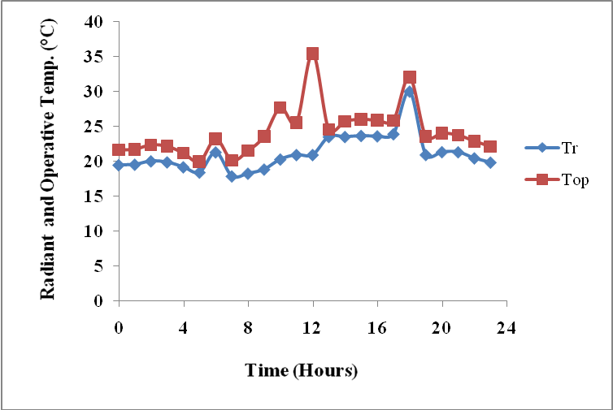
Fig. 4. Radiant $T_{r}$and operative $T_{o}$temperature (ºC) for a clothed man on 16th Ramadan 1429H (17^{h} September 2008).

There are nine full automatic meteorological stations operating around the Holy Grand Haram in Makkah since three years for a special research project. Station No.1 data were selected in calculating the equilibrium temperature $T_{\text{Eq}}$. It is the nearest station installed and neighbored Ajyad Hospital which is also the nearest hospital ever , faced the eastern side of the Holy Grand Masjid. Figures from 6 to 12 were drawn to show the calculated equilibrium temperatures ($T_{\text{Eq}}$ in ºC, blue line in bold), Air temperature ($T_{a}$ in ºC, black line in bold) and wind speed (u in m/s, green line in bold) for the period between 15th Ramadan 1429H (16th September 2008) and 28th Ramadan 1429H (29th September 2008) [some days are missing].
The equilibrium temperatures $T_{\text{Eq}}$ which we have been used when the human being at equilibrium state at 33ºC. Most authors approved this value and they believed that human being feels comfortable. This value of temperature is also skin surface temperature. It is possible to consider this value as a measure. Less than this value, man feels cold while above this value according to$T_{\text{Eq}}$ , he may feel discomfort or may be under severe discomfort.
As seen in Anbar (2010), all figures (6-12) show that always there is an extreme value at midday (1200 hours) of the equilibrium temperature and two minimum values of equilibrium temperature were noticed, one after sunrise, the other before sunset where the human being feels comfortable in those periods. Extreme values of $T_{\text{Eq}}$ were recorded with an average values of 28°C and 35°C on 15th and 16th Ramadan 1429H (16th and 17th September 2008). These values relatively reasonable to get thermal stress throughout the two days.
The extreme value of the equilibrium temperature $T_{\text{Eq}}$ reached as 38°C on 17th Ramadan 1429H (18th September 2008), leading to the feeling of discomfort, and thermal stress with an increase in wind speed (3.5 and 3.75 m/s between 1000 and 1100 hours) and high humidity. While the peak value reached 25 millibars at 1200 hours when the equilibrium temperature was at peak value as well (Fig. 5). The 25th Ramadan 1429H was a day with a distinctive appearance or extraordinary of the curve [the line winding (zigzag) like that occurred on 26th Ramadan, 1430, (Anbar, 2010)]. This guides to the irregularity presence of people (crowds came in and went out the Grand Mosque in Makkah). The rise in equilibrium temperature on this day has nothing to do with moisture, because this day was drier than other days. It was very dry in early morning between 0600 and 0900 hours with a value of 8 millibars. Convergence of the extreme values of the equilibrium temperature $T_{\text{Eq}}$ with the temperature of the air on 25 Ramadan 1429 reaching almost a maximum value of 38°C at 12 hours. There is also an extreme value of $T_{\text{Eq}}$~ 29°C at 1800 hours (Fig. 11 ). The reason here also, is severe overcrowding in these days and nights in particular (the last ten days of Ramadan).
On 28th Ramadan 1429 (29th September 2008), the maximum equilibrium temperature exceeded air temperature at midday by up to 6°C with high humidity of an average of 25 millibars throughout the day. The 6°C difference was never found in any given day in Ramadan, as well as an increase in equilibrium temperature at the highest value in the morning on the same day reaching 28˚C. It is the highest among all the previous days. These results confirm that congestion on this day (last days of Ramadan-Umrah) raised the humidity which reached a water vapor pressure of 25 millibars, as we have seen, and also increased the value of the equilibrium temperature that makes a person really suffer thermal stress.
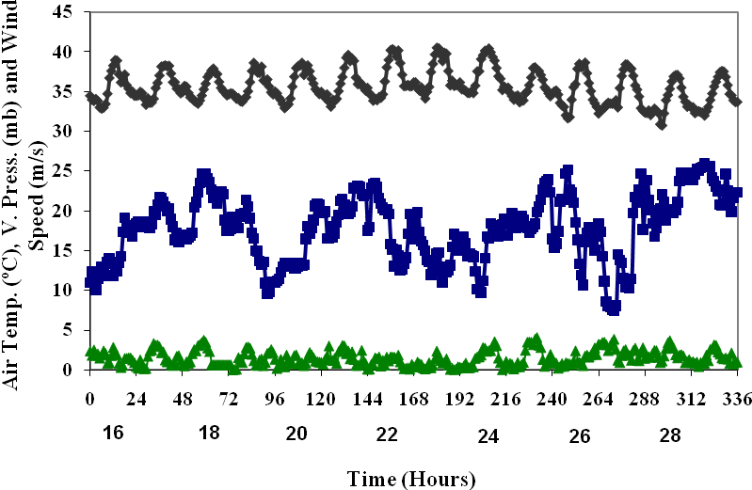
Fig. 5. Air temperature ($T_{a}$ ºC in bold black line), Vapour Pressure ($e_{a}$mb in bold blue line ), Wind speed (m/s in bold green line) between on 15th and 28th Ramadan 1429H (16^{h}-29 September 2008).

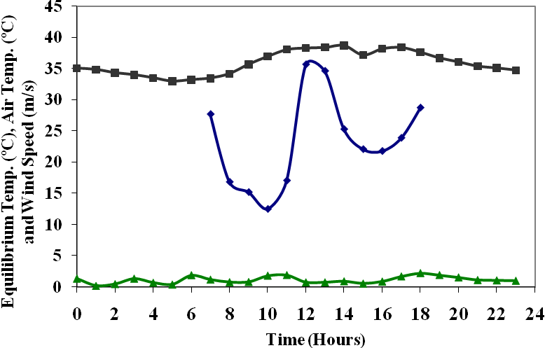
Fig. 6. Equilibrium temperature ($T_{\text{Eq}}$ºC in bold blue), Air temperature ( $T_{a}$ black), Wind speed (m/s in bold green) on 19^{h} Ramadan 1429H (20th September 2008).
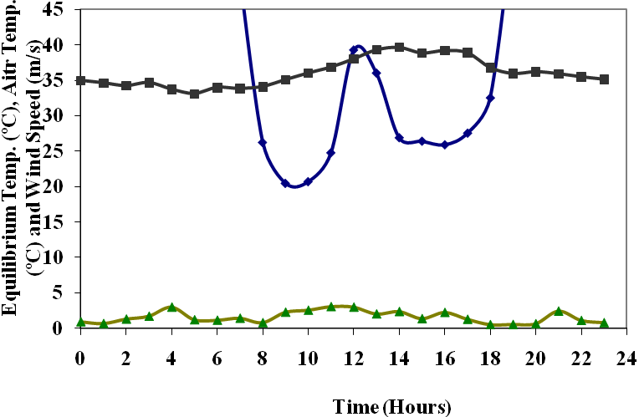
Fig. 7. Equilibrium temperature ($T_{\text{Eq}}$ºC in bold blue), Air temperature ( $T_{a}$ black), Wind speed (m/s in bold green) on 20th Ramadan 1429H (21st September 2008).

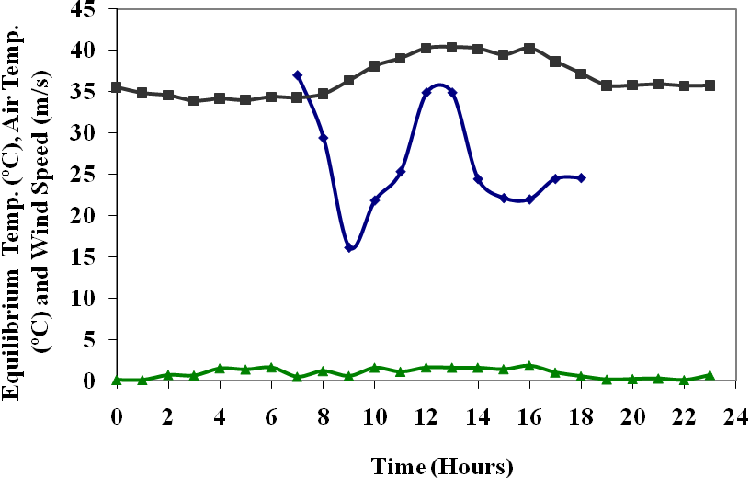
Fig. 8. Equilibrium temperature ($T_{\text{Eq}}$ºC in bold blue), Air temperature ( $T_{a}$ black), Wind speed (m/s in bold green) on 21st Ramadan 1429H (22nd September 2008).
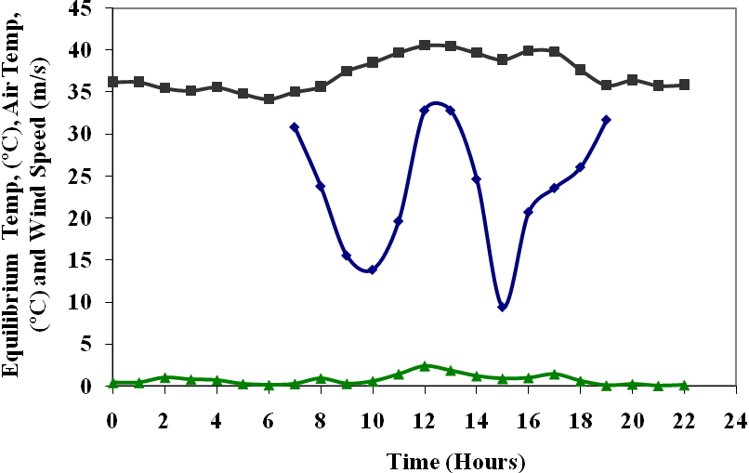
Fig. 9. Equilibrium temperature ($T_{\text{Eq}}$ºC in bold blue), Air temperature ( $T_{a}$ black), Wind speed (m/s in bold green) on 22nd Ramadan 1429H (23rd September 2008).
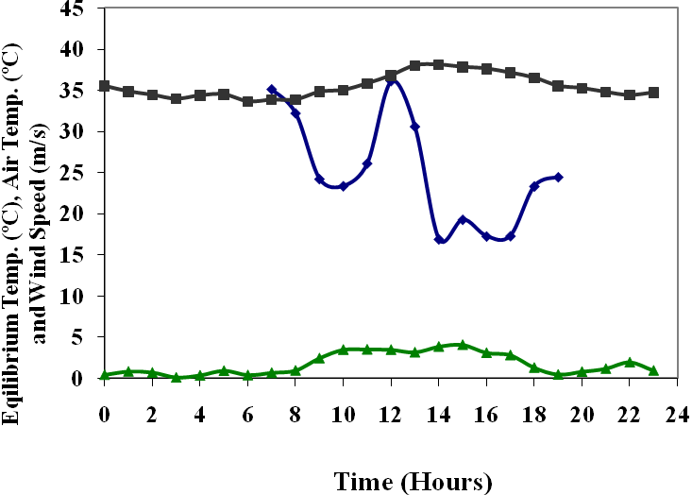
Fig. 10. Equilibrium temperature ($T_{\text{Eq}}$ºC in bold blue), Air temperature ( $T_{a}$ black), Wind speed (m/s in bold green) on 24th Ramadan 1429H (15th September 2008).
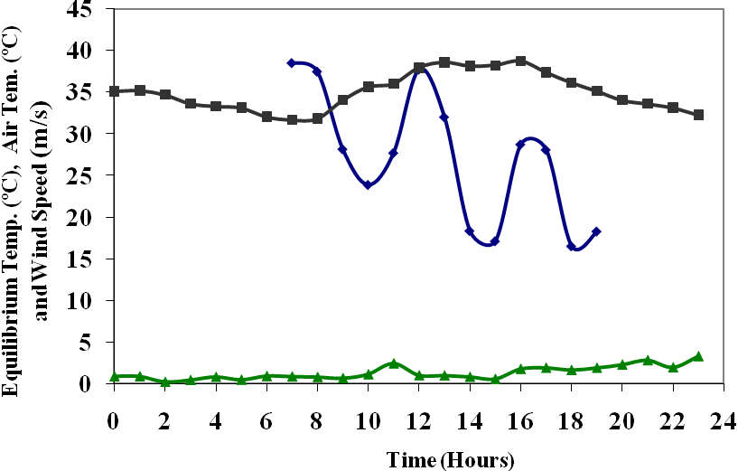
Fig. 11. Equilibrium temperature ($T_{\text{Eq}}$ºC in bold blue), Air temperature ( $T_{a}$ black), Wind speed (m/s in bold green) on 25th Ramadan 1429H (15th September 2008).

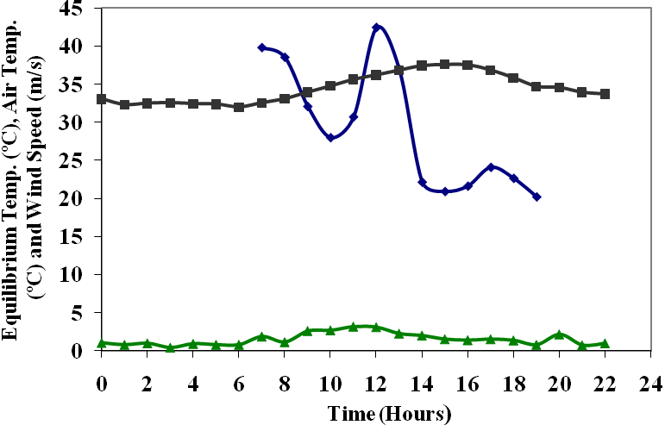
Fig. 12. Equilibrium temperature ($T_{\text{Eq}}$ºC in bold blue), Air temperature ( $T_{a}$ black), Wind speed (m/s in bold green) on 28th Ramadan 1429H (29th September 2008).

From the above results it may be confirmed that the excess of heat or an increase in equilibrium temperature is not strange but matches with the findings of the results Anbar and Hussein (2010) who concluded that: analysis of temperature of the region and around the Haram revealed that there is a difference in temperature inside the area and beyond of 2°C. This might be due to the extreme variation in the nature of the earth's surface within the Haram area compared with the surrounding area, in addition to human activity and weather conditions.
Referring with radiant $T_{r}$ and operative temperatures $T_{\text{op}}$(figs. 3 and 4), It may found that the extreme value of operative temperature on 16th Ramadan was 35°C at 1200 hours while both radiant $T_{r}$ and operative temperatures $T_{\text{op}}$ on 15th Ramadan at 1200 hours show similar values (32°C), Fig. 3) . Another higher values of $T_{r}$ and $T_{\text{op}}$ was noticed on both 15th and 16th Ramadan before sunset. Anyway, it may be not enough to rely on any such calculations because they do not include the most important parameters of the calculations of thermal equilibrium of the human person. It remains to focus on our calculations for the human energy balance.

It is noticed that the values of $T_{\text{Eq}}$ in Ramadan 1429H (fig's from 6 to 12, there are other figures showing higher $T_{\text{Eq}}$ not included in this paper, they may take a large spaces, and we are constrained by the limited pages are higher than in the Ramadan 1430H (Anbar, 2010). Higher values of $T_{\text{Eq}}$ started to appeare earlier before the last 10 days of Ramadan because the crowed in Ramadan 1429H was high rather than in 1430H Ramadan due the fear of (H1 N1, Swan flue), thousands of people were shying away from performing the rituals of pilgrimage (Umra), which was for them like an obligatory.

4. Conclusion

On 28th Ramadan 1429 (29th September 2008), the maximum equilibrium temperature exceeded the air temperature at midday, up to 6°C with high humidity with an average of 25 millibars throughout the day. The 6°C difference was never found in any given day in Ramadan, as well as an increase in equilibrium temperature as the highest value in the morning on the same day reached 28˚C. It is the highest of all the previous days. These results confirm that congestion on this day due to last days of Ramadan-Umrah, raised the humidity which reached its water vapor pressure of 25 millibars, as we have seen, and also increased the value of the equilibrium temperature that makes a person really suffering thermal stress

Acknowledgments

The author would like to thank KACST for providing all instruments needed to use in the field area.

References

1. Anbar O. M. Y. 2010: The Equilibrium Temperatures in the Haram Area,,Makkah
During Ramadan 1429 H and Their Impact on the Umra Pilgrims Comfort I, Al-Azhar Bull. Sci., ?? (?) (?),??-???.

2. Anbar, O. M, Y and Hussein, M. A. 2010: The Micrometeorological Changes in the Haram Area at Makkah During 1428 Haj. JKAU: Met., Env., and Arid Land Agr.
Sci., ??(?), ??-??.

7. Blazejczyk, K., 2001: Assessment of recreational potential of bioclimate based on the human heat balance. [in:] Proceedings of the Fifth International Workshop on Climate, Tourism and Recreation ISB, Commission on Climate, Tourism and Recreation, December2001: www.uni-freiburg.de/isb

4. Cena, K. and Clark, J. 1981: Bioengineering, thermal physiology, and comfort. New York, Elsevier.

10. Chenvidyakarn, T. 2007: Passive Design for Thermal Comfort in Hot Humid Climates. J. Architectural/Planning Res. and Studies, 5 (1), 3-27.

12. Gagge, A. P., Stolwijk, F. A. J. and Hardly, J. D. 1967: Comfort and Thermal Sensations and Associated Physiological Responses at Various Ambient Temperatures. Environ. Res. 1 1-20.

12. Fanger, P. O. 1970: Thermal comfort, analysis and application in environment engineering. Copenhagen, Denmark: Danish Technical Pres.

16. Tanabe, S. Arens E., Bauman, F., Zhang,, H, and Madsen, T, 1994: Evaluating Thermal Environments by Using A Thermal Manikin with Controlled Skin Surface Temperature, ASHRAE Transactions, 100 (1), 39-48.

مستخلص

تم حساب درجة الحرارة التوازن في مكة المكرمة من البيانات المأخوذة من محطة رقم 1 التي تقع في منطقة الحرم المكي الشريف من الناحية الشرقية بجوار مستشفى أجياد باستخدام برنامج حاسوبي المسمى عامل اتزان الطاقة للإنسان للفترة بين 15 رمضان إلى 28 رمضان 1429هـ ( 16 - 29 سبتمبر 2008م). في يوم 17 رمضان 1429هـ (18 سبتمبر 2008م)، ظهرت القيمة القصوى لدرجة حرارة التوازن عند الساعة 1200 ظهراً بقيمة 38 ºم والنتيجة شعور بالانزعاج وإجهاد حراري مع ملاحظة أن سرعة الرياح كانت بين 3.5 م/ث و3.75م/ث بين الساعة 1000 و 1100 صباحاً مع رطوبة عالية أيضاً حيث قيمة الذروة التي بلغتها 25 مليبار عند الساعة 1200 ظهراً، عندها كانت درجة الحرارة التوازن بلغت أقصاها كذلك. يوم 25رمضان 1429هـ كان يوماً مميزاً حيث أخذ شكل المنحنى مظهر الخط المتعرج ((zigzag مثل ما حصل في 26 رمضان 1430هـ (Anbar, 2010)، وهذا دليل على عدم انتظام وجود الناس وشدة الاكتظاظ (الحشود البشرية تأتى وتذهب في منطقة الحرم المكي) في هذا اليوم. الارتفاع في درجة الحرارة التوازن في هذا اليوم لا علاقة له بالرطوبة، لأن هذا اليوم كان أكثر جفافا من الأيام الأخرى. كان الجفاف كبيراً في الصباح الباكر بين الساعة 0600 والساعة 0900 بقيمة 8 مليبار. التقت القيم القصوى لدرجات حرارة التوازن مع درجة حرارة الجو أيضاً في 25 رمضان 1429هـ حيث وصلت إلى ما يقرب من الحد الأقصى بقيمة 38ºم عند الساعة 1200 ظهراً. لوحظ ظهور قيمة قصوى أخرى لدرجة حرارة التوازن بمقدار 29 ºم عند الساعة 1800 مساءً، والسبب هنا أيضا هو شدة الاكتظاظ في هذه الأيام والليالي على وجه الخصوص والتي تكون دائماً في العشر الأواخر من رمضان.
أقصى درجات حرارة التوازن ارتفعت عن قيم درجات حرارة الهواء يوم 28 رمضان (29 سبتمبر) عند منتصف اليوم بـ 6ºم مع رطوبة عالية بلغت 25 مليبار طوال اليوم. يعد الفرق 6 ºم أي الزيادة التي لم تحصل في أي يوم من أيام شهر رمضان، فضلاً عن الزيادة في درجة حرارة التوازن حيث كان الأعلى قيمة في الصباح، في اليوم نفسه حيث وصلت 28ºم. هذه النتائج تؤكد أن الازدحام في هذا اليوم (الأيام الأخيرة من شهر رمضان، العمرة) رفع نسبة الرطوبة الذى وصل ضغط بخار ماءها 25 مليبار، كما رأينا، وكما زادت قيمة توازن درجة الحرارة التي تجعل الشخص حقا يعاني الإجهاد الحراري الحقيقى.

˚

