Impact of marketing insurance products through banks: Indian Perspective

Dr. Hassan A. Shah

Abstract
Bancassurance in its simplest form is the distribution of insurance products through a bank distribution channel. In concrete term, bancassurance which is also known as ‘Allfinanz’- distributes a package of financial services that can fulfill both banking and insurance needs at the same time. It takes various forms in various countries depend upon the demography, economic and legislative climate of that country. Profile of a country decides the kinds of products bancassurance shall be dealing with. Economic situation will determines the trends in terms of turnover, market share etc. Whereas legislative climate will decide the periphery within which the bancassurance has to operate. The motive behind bancasurance varies: For banks- product diversification, source of additional fee income. For Insurance company- A tool of increasing there market penetration, premium turnover, For Customers- Reduced Price, High Quality Product, Delivery at doorsteps. Actually everybody is a winner.
Meaning
Bancassurance¹ simply means selling of insurance products by banks. In this arrangement, insurance companies and banks undergo a tie-up, thereby allowing banks to sell the insurance products to its customers. This is a system in which a bank has a corporate agency with one insurance company to sell its products. By selling insurance policies bank earns a revenue stream apart from interest. It is called as fee-based income. This income is purely risk free for the bank since the bank simply plays the role of an intermediary for sourcing business to the insurance company.
Origin & Global Scenario:
It is most successful in Europe, especially in France, from where it started, Italy, Belgium and Luxembourg. The concept of bancassurance is relatively new in the USA. As mentioned above bancassurance growth differs due to various reasons in different countries. The Glass-Steagall Act of 1933 prevented the banks of the USA from entering into alliance with different financial services providers, thereby putting a barrier on bancassurance. As a result of this life insurance was primarily sold through individual agents, who focussed on wealthier individuals, leading to a majority of the American middle class households being under-insured. With the US Government repealing the Act in 1999, the concept of bancassurance started gaining grounds in the USA also. Coming to Asia, it has been estimated that bancassurance would contribute almost 16% of the life premium in the Asian markets in the year 2006 primarily due to the growth expected in India and China. Middle-East has probably the lowest penetration of bancassurance products. And this has a lot to do with the cultural and religious attitude of the regions pre-dominantly Muslim customers, for whom life insurance in its purely commercial form has been a taboo. But with the development of Shariah-Compliant Takaful Products, Perceptions are beginning to change and there is a wider acceptance of appropriately developed life products.
Development, Growth and Current Scenario of Bancassurance in the Middle East Region² The legal climate in the Middle East is very conducive to bancassurance and is free from hurdles. It is however quite important to study the market and evolve a suitable product profile for the region. Very low penetration levels of insurance in the Middle East, the prospects for bancassurance there are quite bright.
Indian Scenario:
Banking is fully governed by RBI⁴ & Insurance sector is by IRDA⁵
With effect from October 29, 2002, banks have also been allowed to undertake referral business through their network of branches. However, before entering into insurance business, banks are required to obtain prior approval of the Insurance Regulatory and Development Authority (IRDA) and Reserve Bank of India.
It has now been decided that banks need not obtain prior approval of the RBI for engaging in insurance agency business or referral arrangement without any risk participation, subject to the following conditions:
- The bank should comply with the IRDA regulations for acting as ‘composite corporate agent’ or referral arrangement with insurance companies.
- The bank should not adopt any restrictive practice of forcing its customers to go in only for a particular insurance company in respect of assets financed by the bank. The customers should be allowed to exercise their own choice.
- The bank desirous of entering into referral arrangement, besides complying with IRDA regulations, should also enter into an agreement with the insurance company concerned for allowing use of its premises and making use of the existing infrastructure of the bank. The agreement should be for a period not exceeding three years at the first instance and the bank should have the discretion to renegotiate the terms depending on its satisfaction with the service or replace it by another agreement after the initial period. Thereafter, the bank will be free to sign a longer term contract with the approval of its Board in the case of a private sector bank and with the approval of Government of India in respect of a public sector bank.
- As the participation by a bank’s customer in insurance products is purely on a voluntary basis, it should be stated in all publicity material distributed by the bank in a prominent way. There should be no ’linkage’ either direct or indirect between the provision of banking services offered by the bank to its customers and use of the insurance products.
- The risks, if any, involved in insurance agency/referral arrangement should not get transferred to the business of the bank.
ECGC: Corporate agency arrangement with Commercial Banks

Bancassurance is a concept by which the insurance company markets its insurance products through the banks. As the bank has a better network of branches in different places, it is possible for them to market the products of various insurance products at one window. It is also easier for the customers to have one contact point. It is expected that this arrangement besides being mutually beneficial, will benefit the exporting community.

Export Credit Guarantee Corporation⁶ has signed the Corporate Agency Agreements with the following banks for marketing the insurance products of ECGC meant for the exporters:
- Allahabad Bank.
- Andhra Bank.
- Bank of Baroda.
- Bank of India.
- Bank of Rajasthan Ltd.
- Canara Bank.
- Catholic Syrian Bank.
- City Union Bank Ltd.
- Corporation Bank.
- Dena Bank.
- Federal Bank.
- Indian Bank.
- Indian Overseas Bank.
- Karnataka Bank.
- Karur Vysya Bank Ltd.
- Punjab National Bank.
- Saraswat Co-op. Bank.
- South Indian Bank Ltd.
- UCO Bank.
- Union Bank of India.
- United Bank of India.
- Tamil Nadu Mercantile Bank.
- Central Bank of India.
- Syndicate Bank.
- Bank of Maharashtra
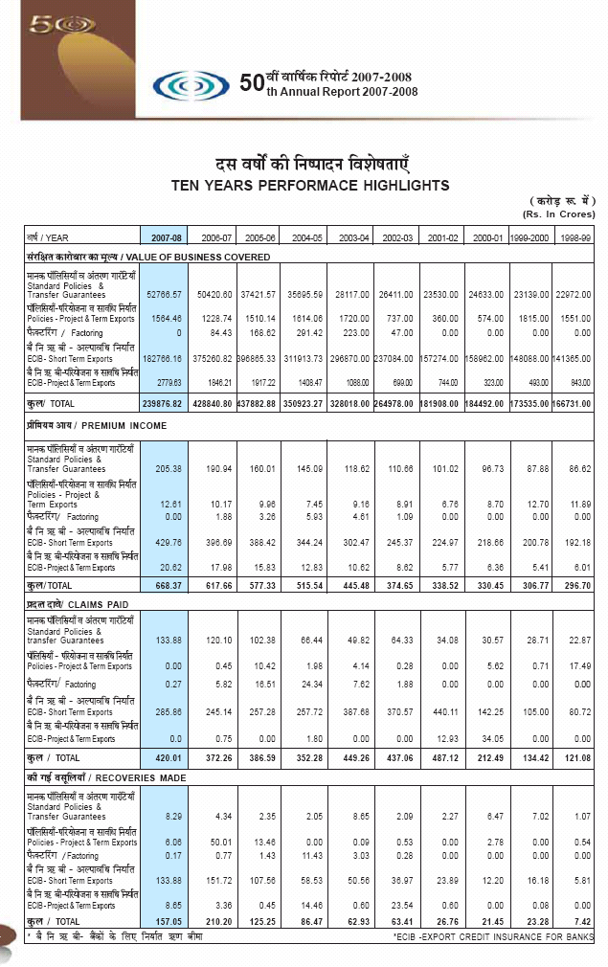
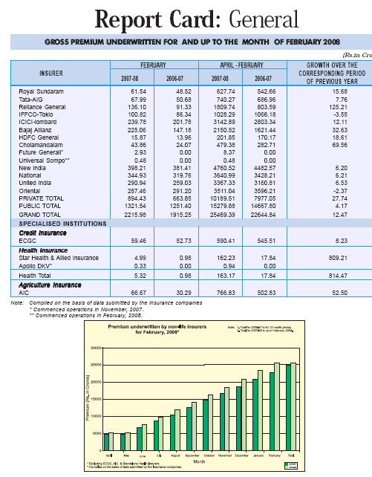
And bank assurance being the combination of two sectors comes under the purview of both the regulators. Each of the regulators has given out detailed guidelines for banks getting into insurance sector.
Coming to India, bancassurance is a new buzzword in India. It originated in India in the year 2000 when the Government issued notification under Banking Regulation Act which allowed Indian Banks to do insurance distribution. It started picking up after Insurance Regulatory and Development Authority (IRDA) passed a notification in October 2002 on 'Corporate Agency' regulations. As per the concept of Corporate Agency, banks can act as an agent of one life and one non-life insurer. Currently bancassurance accounts for a share of almost 25-30% of the premium income amongst the private players in India.
Bancassurance Models³:
Globally we have 3 kinds of bancassurance business models:
Strategic Alliance: Under a strategic alliance, there is a tie-up between a bank and an insurance company. The bank only markets the products of the insurance company. Except for marketing the products, no other insurance functions are carried out by the bank.
Full Integration: This arrangement entails a full integration of banking and insurance services. The bank sells the insurance products under its brand acting as a provider of financial solutions matching customer needs. Bank controls sales and insurer service levels including approach to claims. Under such an arrangement the Bank has an additional core activity almost similar to that of an insurance company.
Mixed Models: Under this approach, the marketing is done by the insurer's staff and the bank is responsible for generating leads only. In other words, the database of the bank is sold to the insurance company. The approach requires very little technical investment.
Most of the bancassurance operations in India fall into the first model, which in a way is quite a prudent decision. The Indian bancassurance scene as of now looks as promising as perilous, being a vast, unexplored and uncharted expanse. As banks are quite risk averse, it is but natural for them to withhold from making any long term commitment, which would be quite costly if the bancassurance business runs into trouble. In terms of the present regulatory framework, one bank can tie-up with only one life and one non-life insurer, while insurers have the choice to tie-up with any number of banks. We also have examples of joint ventures between the bank and insurer such as SBI Life and ICICI Prudential.
SWOT Analysis:
Strengths:
- Vast untapped market
In a country of 1 billion people there is a huge potential market for life insurance products. In India the penetration of the insurance sector in the rural and semi-urban areas is low. There is a market of 900 million for life insurance and 200 million for householder’s insurance policy. In addition to this the affluent section can be tapped for Overseas Mediclaim and Travel Insurance policies.
- Huge pool of skilled professionals
Whether it is banks or insurance companies there is no dearth of skilled professionals in India to carry out a successful bancassurance venture.
Weakness:
- Lack of networking among bank branches
In spite of growing emphasis on total branch mechanization (TBM) and full computerization of bank branches, the rural and semi-urban banks have still to see information technology as an enabler. Complete integration of branch network involves huge investments for creating IT and communication infrastructure.
- Low savings rate
Though we have a huge market for insurance policies, the middle class who constitutes the bulk of this market is today burdened under inflationary pressures. The secret lies in inculcating savings habit but considering the amount of surplus funds available with the middle class for investing in future security, the ability to save is very nominal

Opportunities:
- Data mining
Banks have a huge customer database which has to be properly leveraged. Target segments should be identified and tapped.
- Wide distribution networks of banks provides a great opportunity to sell insurance products through banks
- Another potential area of growth of bancassurance is exploiting the corporate customers and tying up for insurance of the employees of corporate clients
Threats:
- Human Resource Challenges
Success in bancassurance venture requires a change in mindset. Though we have a large talent pool, the inability to sell complex insurance products on the part of bank professionals and their reluctance to learn can be severe setback. There has to be a change in the thinking, approach and work culture.
- Non-response from the target groups can also pose a challenge as it happened in the USA in 1980s.
Conclusion:
With the opening up of insurance sector and with so many players entering the Indian Insurance Industry it is required by Insurance Companies to come up with well established infrastructure facilities with good call centre service to attract and provide information to customer regarding different good policies & their premium pay scheme.
The penetration level of life insurance in the Indian market is abysmally low at 2.3% of GDP with only 8% of the total population currently insured. With almost half of the population likely to be in the 'wage earner' bracket by 2010, there is every reason to be optimistic that bancassurance in India will play a long inning.
Where legislation ahs allowed bancassurance had mostly been a phenomenal success and although slow to gain pace, is now taking of across Asia, especially now that banks are starting to become more diverse financial institution and the concept of universal banking is being adopted.
In the field of bancassurance banks will bring a customer database, leverage their name, recognition & reputation of both local and regional levels. If they are using personal contact with customers and non-customers then only they can success in the field of bancassurance.
But the proper implementation of bancassurance is still facing so many hurdles because of poor manpower management, lack of call centers, and no personal contact with customers, inadequate incentives to agents and unfullfilment of other essential requirements.
Finally we can say that the bancassurance would mostly depend on how well insurers and bankers understanding is with each other and how they are capturing the opportunity and how better service them are providing to their customers. Let us you all pay more attention towards the policies and enjoy the service provide by banks and Insurance Companies by the mode of Bancassurance.
References
- www.wikipedia.com
- www.books.iupindia.org
- www.indiabschools.com
- www.rbi.org.in
- www.irdaindia.org
- www.ecgc.in

