King Abdulaziz University
Faculty of Meteorology, Environment and Arid Land Agriculture
Department of Hydrology and Water Resources Management
1st Term 1430/1431 25/11/1430

HWR 301
Fluid Mechanics
Exercise 3

Assumes the following: Gravitational acceleration, g = 9.81 m/s², Mass density of water, ρ = 1000 kg/m³ and Mercury specific gravity is 13.6

- A rectangular surface 3 x 4 m has the lower has the lower 3 m edge horizontal and 6 m below a free water surface. The surface is inclined 30 with the horizontal. Find the resultant force on the surface and the location of the center of pressure?

- A circular gate of diameter 2 m is located 5 m under free water surface to close a water tank. The gate is hinged at its top. Find the force required to keep the gate closed and the point of application of this force.

- A 5m wide tank with an L-shaped cross section, as shown in Figure 1, has a gate which is hinged at the top at it right hand end. If the tank is filled with water to a level of 8m determine the force (magnitude and location) required at the gate to just keep the gate closed.

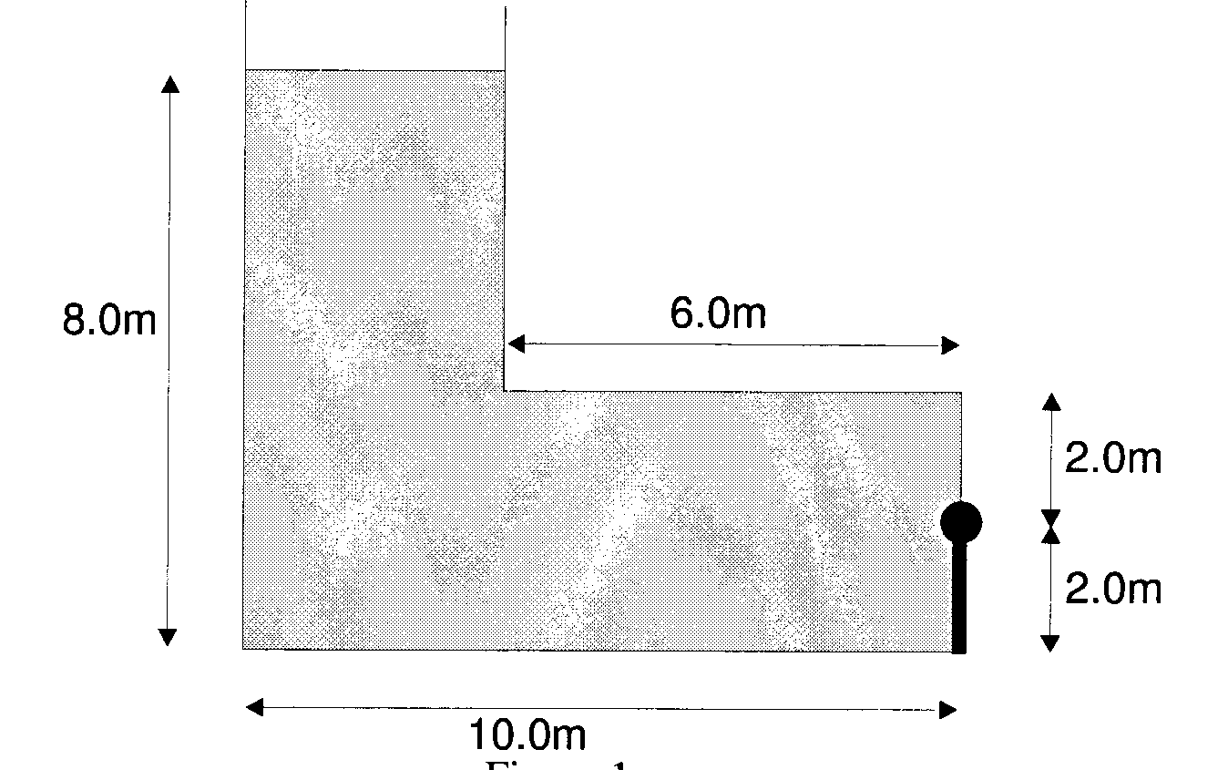

- A dam has the cross-sectional profile composed of a vertical face with a circular curved section at the base as shown in Figure. Calculate the resultant force and its direction of application per unit width of this dam.

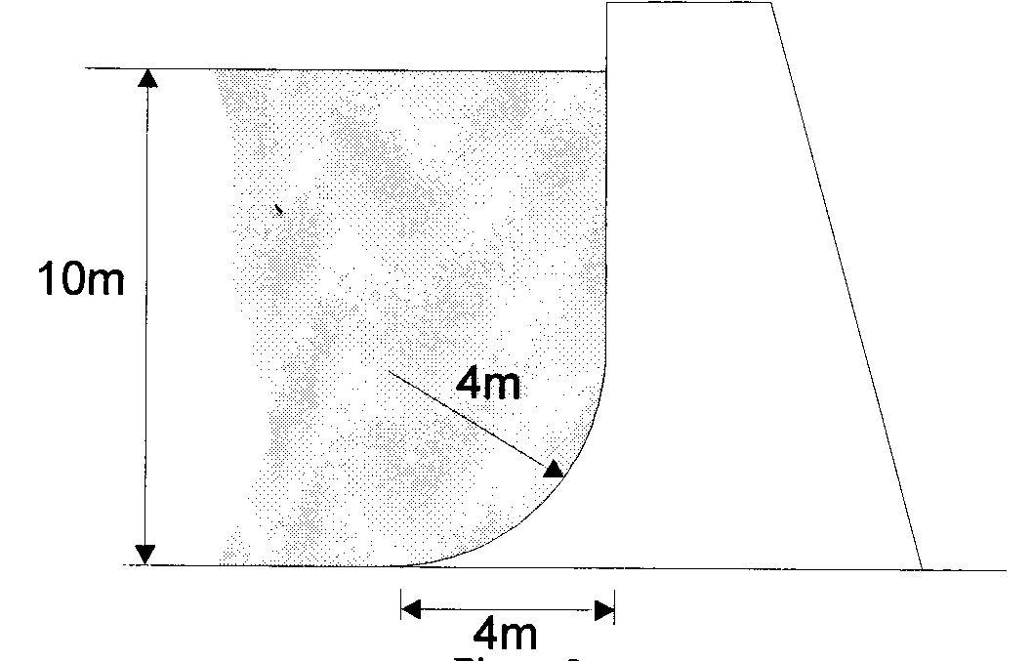

- A dam has a spill way gate at angle of 30⁰, as shown in figure. The gate is hinged at one of its ends such that the end is at the level of the water surface level. The dam is of 2m in width and the gate is of 6cm long. Calculate the resultant force and its directions on the gate surface of the dam design.

