King Abdulaziz University Department of European Languages and Literature
Faculty of Arts and Humanities How To Club
Prepared by Rasha Gazzaz

Some of What You Might Want to Know about Literature

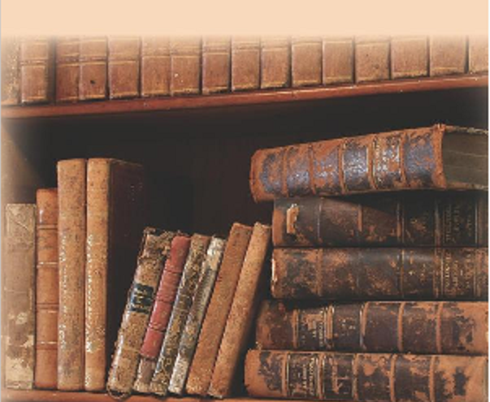
“The Life so short, the craft so long to learn.”

Warm up discussion:
- Literature as a major
- Literature: likes and dislikes
- Diversity and confusion of literature
- Genres of literature

Key points for discussion:
- Appreciation of what you are studying
- Understanding literature is relating to it. Know your artist and read about him/her and the time they lived in. This will help direct you to the path you should read in.
- If you think reading literature stops at the end of the last page of the work, then think again. That is only the beginning. Shakespeare will lead you to Freud (Psychology); Orwell will lead you to Socialism and Communism (Politics); and Wordsworth will lead you to Romanticism (Era).
- Best works are those which defy the norm because they are new in history of writing:
  - Novels: Ernest Hemingway’s The Old Man and the Sea (1952)
  - Dramas: Bernard Shaw’s Pygmalion (1912)
  - Poems: Willaim Butler Yeats’s The Tower (1928)
  - Non-fiction: Olaudah Equiano’s The Interesting Narrative of the Life of Olaudah Equiano, Or Gustavus Vassa, The African (1789) voyage from Africa to Americas and England and Anna Frank’s Het Achterhuis The Diary of a Young Girl (1947)
- Reading works of other nations (French Guy de Maupassant, Colombian Gabriel Márquez, Russian Fyodor Dostoevsky, Arabic Najib Mahfouz) adds to the understanding of Comparative Literature
- Classical references: hardest but the most fun, for example Greek Mythology – Biblical and Eastern references

List of DON’TS:
- Do not forget or misspell:
  - Writer’s name
  - Work’s name
  - Characters’ names
- Do not not know:
  - Era (time of when work is written)
  - Genre (type of work you are reading)
- Do not not read the writer’s biography.
- Do not not read more about what relates to the works:
  - Criticism: scholarly journals criticizing the work
  - History
  - Movement: style in art with a common philosophy or goal (e.g. Romanticism, Realism)
- Do not forget devices and techniques you learned previously, e.g. STILTS (structure, theme, imagery, language, tone, structure).
- Do not read summaries of the works you are supposed to read.
- Do not watch the film adaptation of the written work before reading.
- Do not read the work once.

The Do’s in answering effective literary exam questions and literary analysis:
- Narrow the topic
- Formulate a title that expresses the topic
- Formulate a good topic sentence to control the line of thoughts
- Formulate a good outline the supports the topic sentence
- Be selective in choosing ONLY the examples that support the topic sentence
- Formulate a good conclusion that sums up the analysis
- Use ONLY the simple present in writing
- Answer as much as the question asks for
- Be familiar not only with the literary terms, but also ‘how’ and ‘why’ they are used
- Be familiar with the rules of quotation, citation, and documentation
- Demonstrate a good use of the English writing skills (spelling, grammar, punctuation, etc.)
- Present an academic paper that reflects a good formatting (margin, space, font, etc.)

The Don’ts in answering effective literary exam questions and literary analysis:
- Do not give general interpretation or information
- Do not retell the story
- Do not add irrelevant information
- Do not repeat the same idea
- Do not use these pronouns: I, you, we
- Eliminate the use of ‘he’ and ‘she’
- Eliminate the use of ‘it’
- Eliminate the use of ‘say’ and ‘describe’
- Eliminate the use of transitional words
- Eliminate the use of ‘first’, ‘second’, ‘third’ etc. in listing the order of
- Do not use general vocabularies such as ‘very good’, ‘very bad’, ‘like’, ‘hate’, ‘thing’, ‘something’, ‘as you know’, ‘it is clear’, etc.

Conclusion (Advices):
- Literature is a link to life. It teaches you through a story, a poem, or a play the lessons learned by those who write the work.
- Trying to enjoy what you read is not easy because sometimes you will read works you do not like or understand.
- Must read list: make a list of the works you know you must read and make sure you read them before graduating. Ask your instructors for suggestions.
- Writing is the by-product your education in the English Language Department: Experience is the best way to start – write about your experiences – if you feel you do not have anything worthwhile to write about, you are wrong!! Think deeper, for there is always more to the story than what you think.

Useful Websites:
- http://www.socsdteachers.org/tzenglish/literature_timeline.htm
- http://andromeda.rutgers.edu/~jlynch/Lit/
- http://www.bartelby.com/cambridge/index.html
- http://www.gutenberg.org/wiki/Main_Page
- http://www.slsa.sa.gov.au/site/page.cfm?u=181

Pygmalion (1912) by Bernard Shaw will lead you to the world of Linguistics.
The Tower is a collection of poems, entailing “Sailing to Byzantium” and “Leda and the Swan,” two of Yeats’s well-known poems.
“I Wandered Lonely” is not a novel; Pride and Prejudice is not a play; and Macbeth is not a poem!
Techniques and devices are used in all genres of literature. Some are used in more than one genre. For example, symbols can be found in novels, plays, and poems.

