Course Portfolio

Faculty of science

mathematics Department

COURSE NAME:

COURSE NUMBER:
  M | A | T | H | 3 | 3 | 1
SEMESTER/YEAR: | 2nd semester | 1429
DATE:

PART II


COURSE SYLLABUS

Instructor Information

Name of the instructor: | 1-Dr/Eman Salem Al-Aidarous  2-Dalal Maturi  3- Doaa Garout  Science Collage.. Mathematics Department  Tel. 6400000 ext. 000  Office B-159  Email : : ealaidarous@Kau.edu.sa  dgarout@kau.edu.sa  dmaturi@kau.edu.sa
الساعات المكتبية | Office hours:
مواعيد المحاضرات:  1- د/ايمان العيدروس  2- أ/ دلال مطيوري  3- أ/ دعاء قاروت
  Day | Sat | Sun | Mon | Tue | Wed
  Time | 10-11 |  | 10-11 | 12:30-1:30 | 10-11
  Day | Sat | Sun | Mon | Tue | Wed
  Time | 8-9 |  | 8-9 | 11-12 | 8-9
  Day | Sat | Sun | Mon | Tue | Wed
  Time | 9-10 | 12-1 | 9-10 |  | 9-10

Course Information

Course name: | Programing and mathematical programs
Course number: | Math.331
Description of the course: | I How to write an Essay.  II Introduction to Scientific Work Place.  III Introduction to Maple  VI Introduction to Matlab.

Course Objectives

The main goal of this course is to provide students with the skills judgment and spirit necessary to effectively use a symbolic mathematics system such as Maple and Matlab. Students will learn the features and limitations of those softwear and related systems. Through a collection of examples provided in lecture and homework problems students will see how Maple and Matlab can be used to solve a wide range of computational and mathematical problems.

Learning Resources

Main Text book:  الكتاب الأساسي | - Maple 8 Getting Started Guide. Maple 9.5, Learning Guide. Maple 9.5, Introductory Programming Guide  - Essential MATLAB for Scientists and Engineers  B. Hahn  - Doing Mathematics with Scientific WorkPlace and Scientific Notebook By Susan Bagby.  - Creating Documents with Scientific WorkPlace and Scientific word. By Susan Bagby.

Course Requirements and Grading

Student assessment:  توزيع الدرجات و مواعيد الاختبارات | First Exam. 14/3/1429 10 %  Second Exam. 17/4/1429 15 %  Third Exam 16/5/1429 15%  Section 15%  Report 23/2/1429 5%  Project 21/5/1429 10%  Final Exam. 30%
Rules and Course Requirements:  1- Students is responsible to attend exams and  deliver projects on time appointed.  2- No repeat for any examination. The mark of  an exam that a student missed with an  acceptable excuse is added to the mark of final  Exam.  3- A student that exceeds a 20% of being absent  with no acceptable excuse is deprived from  Entering the final exam.  4- the requirement for a student to have IC grade  Is :1 attending all exams prior to the final  Exam...2. not exceeding a 20% absent time..3  An official illness report.  5- Punishment for in quizzes and mid exam. Is  Failing the course.  6- Punishment for cheating in final exam is  failing the course and expel from university  For the following term. | 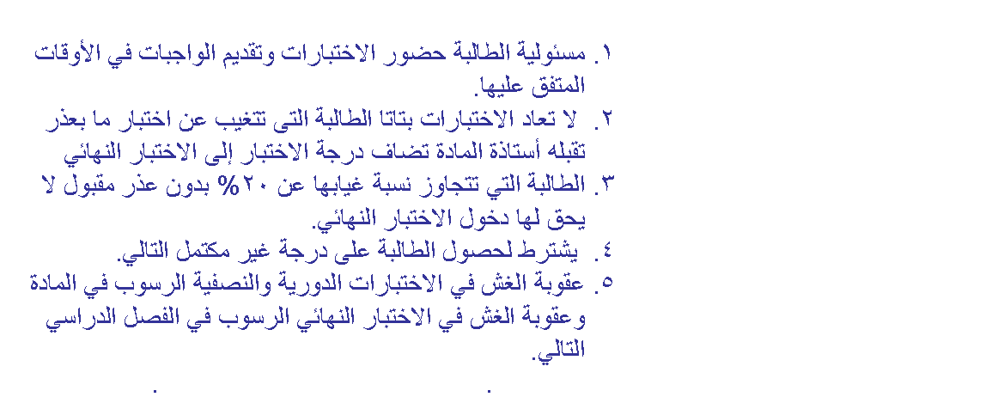

Consept

- | Date | period | Title | Whats is due ?
1 | 18-2-1429،  20-2-1429 | 3 Days  3 Hours | مقدمة | جولة ميدانية للمكتبة وكيفية استخدام مرافقها المختلفة
2 | 23-2-1429 إلى  26-2-1429 | 3 Days  3 Hours | مقدمة | كيفية انشاء الأيميل الجامعى وتعلم اسس البحث العلمي عن مختلف المواضيع باستخدام الأنترنت
3 | 23-2-1429 إلى  26-2-1429 | 3 Days  3 Hours | كيفية كتابة بحث علمى | How to write an essay
4 | 27-2-1429 إلى  14-3-1429 | 3 Days  3 Hours | SW | Introduction to Scientific WorkPlace
5 | 27-2-1429 إلى  14-3-1429 | 3 Days  3 Hours | SW | Doing Mathematics Calculus
6 | 16-3-1429 إلى  3-4-1429  ثم  13-4-1429 إلى  17-4-1429 | 3 Days  3 Hours | Maple | Introduction to Maple Editing functions Opening and saving documents Common command
7 | 16-3-1429 إلى  3-4-1429  ثم  13-4-1429 إلى  17-4-1429 | 3 Days  3 Hours | Maple | Plotting 2D Plotting 3D Vectors and matrices
8 | 16-3-1429 إلى  3-4-1429  ثم  13-4-1429 إلى  17-4-1429 | 3 Days  3 Hours | Maple | Control Flow Do Loops Condition statements
9 | 20-4-1429 إلى  16-5-1429 | 3 Days  3 Hours | Matlab | Introduction to MatLab Vectors and matrices Plotting 2D & 3D
10 | 20-4-1429 إلى  16-5-1429 | 3 Days  3 Hours | Matlab | Curves Fitting Logic and Loops Direct/indirect linear system solver
11 | 20-4-1429 إلى  16-5-1429 | 3 Days  3 Hours | Matlab | ODE PDE Non-Linear equations solver
12 | 20-4-1429 إلى  16-5-1429 | 3 Days  3 Hours | Matlab | Math world problems
13 |  | 6 Days  6 Hours | مراجعة | مراجعة لجميع ماسبق مع تطبيقات

PART III

COURSE RELATED MATERIAL

Contains all the materials considered essential to teaching the course, includes:

Quizzes, lab quizzes, mid-terms, and final exams and their solution set
Paper or transparency copies of lecture notes/ handouts (optional)
Practical Session Manual (if one exists)
Handouts for project/term paper assignments

(use the following template for Quizzes, lab quizzes, mid-terms, and final exams and their solution set)

King Abdul Aziz University  Faculty of Science  Mathematics Department |  | Math 331 - Exam 1  2nd Semester 2008  Date: (the exam date)  Time allowed: (time allowed)

Q1 | (Insert question one here) | 8 marks
Q2 | (Insert question two here) | 8 marks
Q3 | (Insert question three here) | 8 marks
Q4 | (Insert question four here) | 8 marks
Q5 | (Insert question five here) | 8 marks
 | Total | 25

