Firearm Injuries

Firearms
Firearms may be considered, in the simplest form, to be of five main types:
1. Guns firing single missiles—rifles and pistols.
2. Guns firing a mass of small missiles, or shot—shotguns.
3. Air-guns
4. Automatic Rifles
5. Military Weapons
Rifles and Pistols

These are also known as rifled weapons, after the rifling or spiral grooving of the inside of the barrel, designed to impart a spin to the missile or bullet, and so to ensure a steady flight by the gyroscopic effect produced.

Weapons with a long barrel, 2-3 feet (0.6-0.9m) long, are known as rifles. These are designed to fire the missile at a very high speed, or muzzle velocity, about 1000-4000 feet /second, and are accurate at a considerable range. Short-barrelled weapons, 1-12 inch (25-300mm) long, are known as pistols, have a low muzzle velocity, 600-1000 feet/second, and are only accurate at relatively short range.
Pistols are of two types, revolvers and automatic pistol:

a) Revolvers (Fig. 1) are so called because the-ammunition is put in chambers in a metal cylinder which revolves before each shot to bring the next live round opposite the barrel, ready to be fired. After the bullet has been discharged the cartridge case, the brass case which contained the explosive, remains in the cylinder, and must be removed by hand.

b) Automatic (or self-loading) pistol (Fig. 16. la) has the ammunition stored in a magazine, usually in the butt or handle of the gun, from which each round is fed into the barrel by a spring when the previous round has been fired. The empty cartridge case from the round that has been fired is automatically ejected from the pistol, landing on the ground several feet away.

The size or calibre of all these weapons is expressed as the internal diameter of the barrel, e.g. 0.303 inches for a rifle and 0.45 inches for a large pistol.The missiles for these weapons consist of a solid metal bullet, which is being struck by the hammer released by the trigger of the gun, detonates the main part of the explosive.Most of these guns have a safety catch, a device which can lock the firing mechanism and prevent the gun being discharged accidentally.

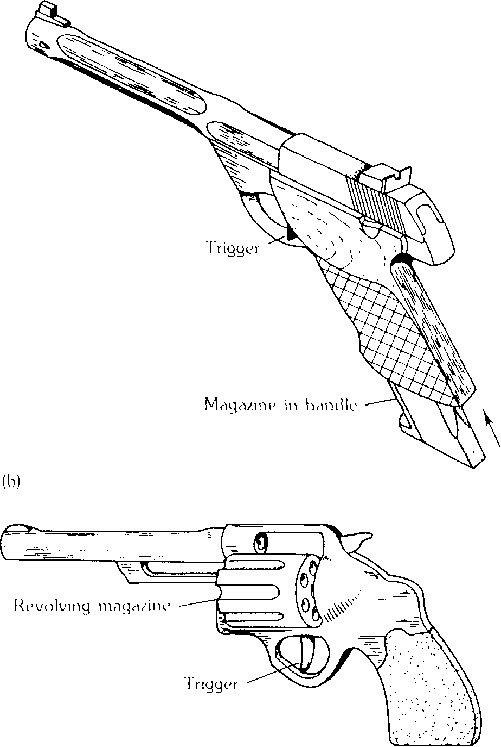
Fig. 1 (a) Automatic pistol; (b) Revolver.

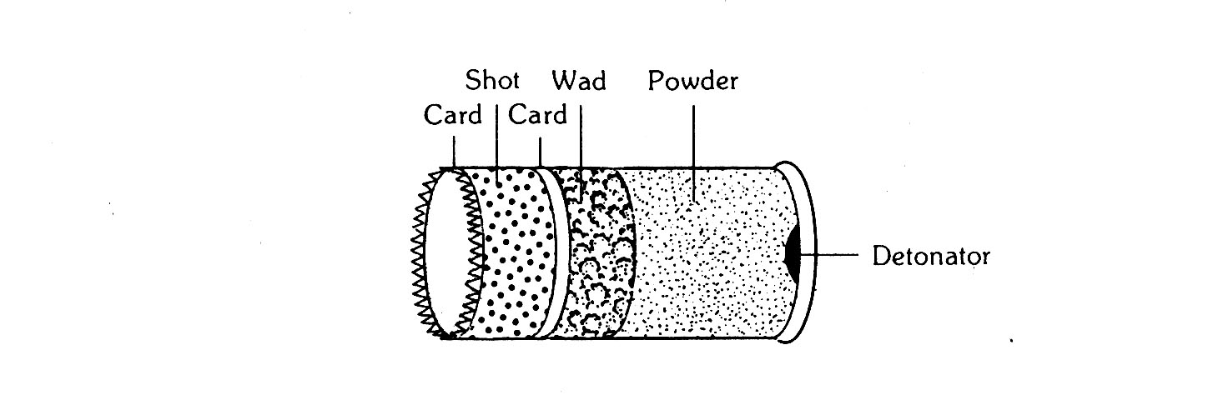

Fig. 2 Diagrammatic cross-section of shot-gun cartridge.

Shot-guns

These are made for shooting game; the inside of the barrel is smooth, an. the gun is designed to fire a composite missile consisting of a small lead pieces.

The size or calibre may either be expressed as the inside diameter of the barrel, e.g. 0.410 shot-gun, or by an archaic measurement, the bore, e.g. 12-bore shot-gun. This refers to the number of balls of lead, exactly fitting the barrel, which could be made from a pound of lead.

The cartridge consists of a cardboard cylinder, with a brass base, in the centre of which is a detonator (Fig. 2). The cartridge contains a mass of tiny lead shot )approx. 300), each about ⅛ inch (3 mm) diameter, held in place by cardboard discs. At the bottom of the cylinder is the explosive powder, and between it and the shot is a thick cardboard disc, or wad, which functions as a piston, driving the shot before it down the gun barrel.

The shot leave the gun barrel as a solid mass, but gradually fan out during their passage through the air, so that the effect of the shot at close range is of one solid missile, at a few yards it is of a solid missile surrounded by several separate pellets, and at greater distances, it is of many separate individual pellets. The cardboard discs and the wad leave the gun with the shot, and travel for several feet before falling to the ground. Therefore in injuries caused at close range they may be found in the wound with the mass of shot.
Air-guns

These are common as adolescents' weapons, and may be of rifle or pistol type. The propellant is compressed air and the missile is a metal pellet or dart. Such weapons can be dangerous or even lethal at short ranges. Some weapons use cartridges of liquid CO2 as the propellant, and in external appearance resemble very closely the normal revolver or automatic pistol.
Firearm Wounds
1. Bullet Wounds

These are produced by a single missile traveling at high velocity. As the bullet enters the body it generally produces a round hole with clean-cut skedges, slightly smaller than the bullet. While the missile is traveling through the body shock waves are caused, which spread laterally into the tissue producing a large cavity in the track of the missile several times wider than the diameter of the bullet. This cavity only persists for a fraction of a second and the track of the missile within the body will be represented by a broad band of damaged tissue. The bullet will be slowed by its passage through the tissues so that if it leaves the body its exit wound will usually be an irregular split in the skin with everted edges, rather than a clean-cut hole.

The entrance wound may have special features (Fig. 3), depends on the distance between the muzzle and the body when the gun is fired, for example:

1 Muzzle pressed against skin (contact injury). The gases produced by the explosion of the cartridge will enter through the skin with the missile and they meet underlying bone, e.g. the skull, may be reflected, everting an splitting the skin at the margins of the entrance wound to produce cruciform-shaped tear. The tissue at the margin of the wound may contain soot and powder, and carbon monoxide derived from the gases. The recoil of the gun barrel may produce a circular bruise on the skin beside the entrance wound.

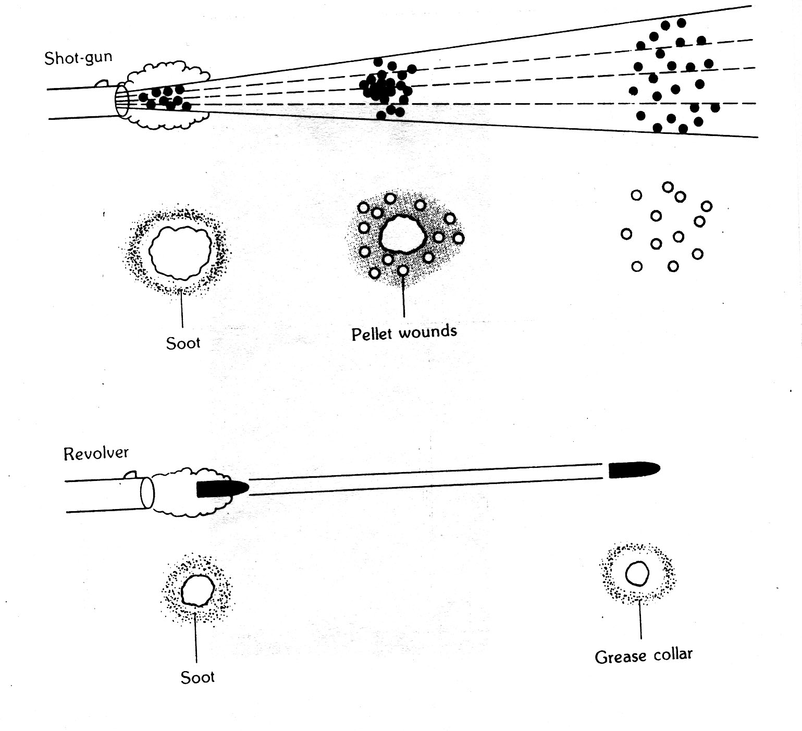
Fig. 3 Firearm wounds.

2. Shot-gun Wounds

Unlike bullet wounds, it is rare for shot-guns to have an exit wound, as the shot tend to scatter within the body. The track of the missile or mass of shot within the body is broader and more ragged than is the case with a bullet.

The nature of the entrance wound (Fig. 3) varies with the range:
Contact injury. If the muzzle is applied to the forehead, or the roof of the mouth, the greater part of the head, including the actual entrance wound, may be destroyed.

On the trunk the wound will present as a rounded hole, with a very narrow rim of blackening by soot at the skin edges. Soot, powder and carbon monoxide will contaminate the tissues at the margins of the wound, beneath the skin.

Recoil of the gun barrel may graze or bruise the skin beside the entrance wound.
At close range—up to 1 yard (1m). There may still be gross destruction of the head. Elsewhere, the shot will enter the body as a solid mass, producing a round or oval hole about 1 inch (25mm) diameter, with slightly ragged margins and with considerable blacking of the surrounding skin by soot and singeing of hair by flame unless the wound is produced through clothing. At this range the cards and wad from the cartridge will be blown into the wound along with the shot.
At intermediate ranges—about 1-4 yards (1-3.5 m). The bulk of the shot will still be traveling as a composite mass, but some individual shot pellets around the periphery will have begun to diverge. Thus the wound will appear as a central hole, with several tiny separate holes each up to ⅛ inch (3 mm) diameter, in the skin around the margin. There will be no naked eye evidence of soiling by soot or powder at this range, although traces may be found on swabs taken from the area of the wound. Cards and wad may be found in the wound.
At long range—over 4 yards (>3.5 m). As the range increases the shot will become increasingly separated and the wound at more than 10 yards (9 m) range approximately, will consist of a mass of separate tiny holes due to pellet wounds, in inches, and subtracting one, when the result will indicate the range in yards, e.g. wound 6 inch (1.5 cm) diameter, range 5 yards (4.5 m). This should only be used for a very rough estimate, since individual weapons vary considerably, and for greater accuracy test firings with the weapon must be made (see below).
3. Air-gun Wounds

The pellet produces a tiny hole, like the individual shot from a shot-gun. However close the range, there will be of course no soiling by soot or powder. The wounds are usually not fatal, but may be so in a child, or if the pellet injuries a large blood vessel. Although rarely fatal they are liable to produce severe injuries, e.g. the loss of an eye.
Interpretation of Firearm Injury
From external examination
The primary object, of course, is to distinguish between homicide, suicide and accident. For this, note must be taken of:
- The probable type of weapon which caused the injury.
- The site of the wound.
- The range of discharge.

Thus, in the case of suicide, the wound must be capable of self infliction, from its site (classically in the temple, forehead or mouth or over the heart) and the range of discharge (which must be at a range at which the deceased could reach the trigger unless some gadget has been devised to fire the gun from a distance).

In the case of homicide, the wounds may also be in such situations, but often they are in odd sites such as the neck or the back of the body, and at longer range. They may be multiple.

An accidental shooting may of course be by the deceased or by another, and has no features distinctive of accident. Such a case must be determined by exclusion of homicide and suicide, and by the attendant circumstances.
A bullet may have scratches on its surface which have been produced by the barrel of the gun, and which are characteristic of that gun, so that comparison of the bullet recovered from the body with bullets fired from various weapons will enable the forensic scientist to identify the gun which was use Similarly a cartridge case bears marks produced by the firing mechanism from which it is possible to identify the gun from which it was fired.

Therefore it is very important that all such objects, especially the missing during its removal from the body, should be treated very carefully, to avoid altering or erasing the surface markings, e.g. the ends of forceps should be wrapped in gauze before the missile is gripped.

In the case of shot-gun wounds, the cards or wads, and as much shots possible must be collected, to determine the type of cartridge used. If the missile cannot be easily found, then much time is saved by having the body X-rayed, since a bullet can change direction on hitting bone and end up in some very remote part of the body.

