Chapter II
Applications of Conic Sections
Mathematicians have a habit of studying, just for the fun of it, things that seem utterly useless; then centuries later their studies turn out to have enormous scientific value.
There is no better example of this than the work done by the ancient Greeks on the curves known as the conics: the ellipse, the parabola, and the hyperbola. They were first studied by one of Plato's pupils. No important scientific applications were found for them until the 17th century, when Kepler discovered that planets move in ellipses and Galileo proved that projectiles travel in parabolas.
Appolonious of Perga, a 3rd century B.C. Greek geometer, wrote the greatest treatise on the curves. His work "Conics" was the first to show how all three curves, along with the circle, could be obtained by slicing the same right circular cone at continuously varying angles.

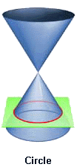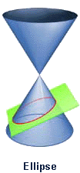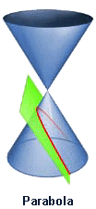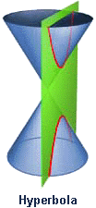
Apollonius's work was translated into Arabic and much of his work only survives through the Arabic version. Muslims found applications to the theory; the most notable of these was the Persian mathematician and poet Omar Khayyám who used conic sections to solve algebraic equations.
The General Equation for a Conic Section:
Ax² + Bxy + Cy² + Dx + Ey + F = 0
The type of section can be found from the sign of: B² - 4AC
If B² - 4AC is... | then the curve is a...
< 0 | ellipse, circle, point or no curve.
= 0 | parabola, 2 parallel lines, 1 line or no curve.
> 0 | hyperbola or 2 intersecting lines.
Circle  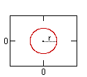 | Ellipse (h)  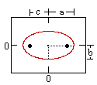 | Parabola (h)  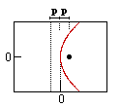 | Hyperbola (h)  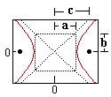
Definition:  A conic section is the intersection of a plane and a cone. | Ellipse (v)  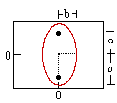 | Parabola (v)  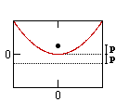 | Hyperbola (v)  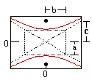

 | Circle | Ellipse | Parabola | Hyperbola
Equation (horiz. vertex): | x² + y² = r² | x² / a² + y² / b² = 1 | 4px = y² | x² / a² - y² / b² = 1
Equations of Asymptotes: |  |  |  | y = ± (b/a)x
Equation (vert. vertex): | x² + y² = r² | y² / a² + x² / b² = 1 | 4py = x² | y² / a² - x² / b² = 1
Equations of Asymptotes: |  |  |  | x = ± (b/a)y
Variables: | r = circle radius | a = major radius (= 1/2 length major axis)  b = minor radius (= 1/2 length minor axis)  c = distance center to focus | p = distance from vertex to focus (or directrix) | a = 1/2 length major axis  b = 1/2 length minor axis  c = distance center to focus
Relation to Focus: | p = 0 | a² - b² = c² | p = p | a² + b² = c²
Definition: is the locus of all points which meet the condition... | distance to the origin is constant | sum of distances to each focus is constant | distance to focus = distance to directrix | difference between distances to each foci is constant

1. THE ELLIPSE
Though not so simple as the circle, the ellipse is nevertheless the curve most often "seen" in everyday life. The reason is that every circle, viewed obliquely, appears elliptical.  Tilt a glass of water and the surface of the liquid acquires an elliptical outline. | 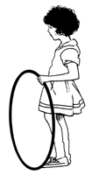
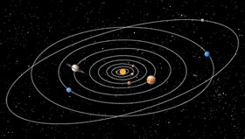 | The early Greek astronomers thought that the planets moved in circular orbits about an unmoving earth, since the circle is the simplest mathematical curve. In the 17th century, Johannes Kepler eventually discovered that each planet travels around the sun in an elliptical orbit with the sun at one of its foci.
The orbits of the moon and of artificial satellites of the earth are also elliptical as are the paths of comets in permanent orbit around the sun.

Halley's Comet takes about 76 years to travel abound our sun. Edmund Halley saw the comet in 1682 and correctly predicted its return in 1759. Although he did not live long enough to see his prediction come true, the comet is named in his honor.
 | On a far smaller scale, the electrons of an atom move in an approximately elliptical orbit with the nucleus at one focus.
Reflective property of the ellipse  The ellipse has an important property that is used in the reflection of light and sound waves. When a ray leaves one of the foci and meets a point on that ellipse, it will reflect off of the ellipse and pass through the other focus. This principle is used in lithotripsy, a medical procedure for treating kidney stones as we will show later. | 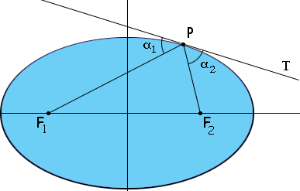
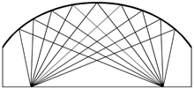 | The principle is also used in the construction of "whispering galleries" such as in St. Paul's Cathedral in London. If a person whispers near one focus, he can be heard at the other focus, although he cannot be heard at many places in between.
Statuary Hall in the U.S. Capital building is elliptic. It was in this room that John Quincy Adams, while a member of the House of Representatives, discovered this acoustical phenomenon. He situated his desk at a focal point of the elliptical ceiling, easily eavesdropping on the private conversations of other House members located near the other focal point. | 
Example 2.1: The maximum distance between the earth and the sun is 152×10⁶ Km, the minimum distance is 147×10⁶ Km. The sun is at one focus of the elliptical orbit of earth. Find the distance from the sun to the other focus.
Solution:

Example 2.2: A room is elliptic with vertical walls and an ellipsoidal ceiling. If the ceiling is 40 feet long and 20 feet wide, where should two people stand (other than next to each other) so that they can whisper to each other without being heard by others in the room?
Solution:

Example 2.3: Lithotripsy
Extracorporeal Shock Wave Lithotripsy (ESWL) is the non-invasive treatment of kidney stones. The patient is placed in an elliptical tank of water, with the kidney stone at one focus. High-energy shock waves generated at the other focus are concentrated on the stone, pulverizing it. If the end points of the major axis of the tank are located 6 inches from the center, and the end points of the minor axis are located 2.5 inches from the center. Where is the point where the kidney of the patient should be?
Solution:

Example 2.4: Suppose a satellite is in an elliptical orbit, with a = 4420 and b = 4416, and with the center of the Earth being at one of the foci of the ellipse. Assuming the Earth has a radius of about 3960 miles; find the lowest and highest altitudes of the satellite above the Earth.
Solution:

2. The Parabola
One of nature's best known approximations to parabolas is the path taken by a body projected upward and obliquely to the pull of gravity, as in the parabolic trajectory of a golf ball.. | 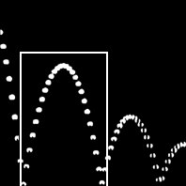
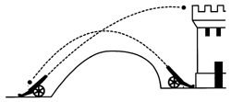 | This discovery by Galileo in the 17th century made it possible for cannoneers to work out the kind of path a cannonball would travel if it were hurtled through the air at a specific angle.
When a baseball is hit into the air, it follows a parabolic path; the center of gravity of a leaping porpoise describes a parabola. | 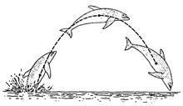
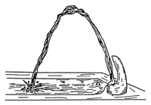 | The easiest way to visualize the path of a projectile is to observe a waterspout. Each molecule of water follows the same path and, therefore, reveals a picture of the curve.
Reflective property of the parabola  Parabolas exhibit unusual and useful reflective properties. If a light is placed at the focus of a parabolic mirror (a curved surface formed by rotating a parabola about its axis), the light will be reflected in rays parallel to axis. In this way a straight beam of light is formed. It is for this reason that parabolic surfaces are used for headlamp reflectors. The bulb is placed at the focus for the high beam and a little above the focus for the low beam. | 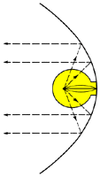
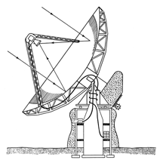 | The opposite principle is used in the giant mirrors in reflecting telescopes and in antennas used to collect light and radio waves from outer space: the beam comes toward the parabolic surface and is brought into focus at the focal point.
Heat waves, as well as light and sound waves, are reflected to the focal point of a parabolic surface. If a parabolic reflector is turned toward the sun, flammable material placed at the focus may ignite. A solar furnace produces heat by focusing sunlight by means of a parabolic mirror arrangement. Light is sent to it by set of moveable mirrors computerized to follow the sun during the day. Solar cooking involves a similar use of a parabolic mirror. | 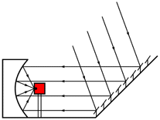
Example 2.5: A car headlight mirror has a parabolic cross section with diameter 6 inches and depth 1 inch. Find the equation of the parabola. How far from the vertex should the pulp be positioned if it is to be placed at the focus?

Example 2.6: An engineer designed a satellite with a parabolic cross section. The dish is 15 ft wide at the opening and the focus is placed 4 ft from the vertex. Find the equation of the parabola, and then find the depth of the satellite dish at the vertex.

Example 2.7: A field microphone used at a football game has a parabolic cross section and is 18 inches deep. The focus is at 4 inches from the vertex. Find the width of the microphone at the opening.

Example 2.8: A comet from deep space approaches the sun along a parabolic orbit. When the comet is 100 million miles from the sun, the line joining the sun and the comet makes an angle of 60º with the axis of the parabola. How close to the sun will the comet get?

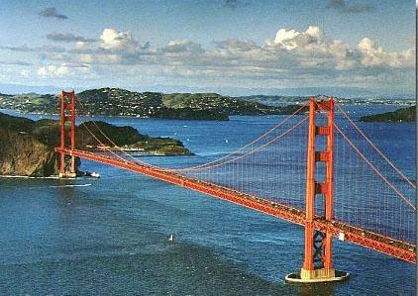
Parabolas and Bridges
Parabolas also occur in certain engineering
applications. If you hang a bridge from a
pair of towers by vertical cables that are
uniformly spaced along the length of
the bridge, then the curve of the suspension
cables becomes approximately a parabola.
Example 2.9:
The cables of a suspension bridge are 50 ft
above the roadbed at the ends of the bridge
and 10 ft above it at the center of the bridge.
The roadbed is 200 ft long. Vertical cables
are to be spaced every 20 ft along the bridge.
Calculate the length of these vertical cables.

Parabolic Motion of a Projectile
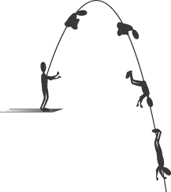
Let us define projectile motion as the motion of a
particle through a region of space where it is subject
to constant acceleration. An object moving through
the air near the surface of the earth is subject to the
constant gravitational acceleration g, directed downward.
If no other forces are acting on the object, and we neglect air resistance,
then the motion of the object is projectile motion.
Assume that we want to describe the motion of such an object, starting at time t = 0. Let us orient our coordinate system such that one of the axes, say the y-axis, points upward. Then a = a_{y}j =- gj, a_{y} = -g. We can rotate our coordinate system about the y-axis until the velocity vector of the object at t = 0 lies in the x-y plane, and we can choose the origin of our coordinate system to be at the position of the object at t = 0.
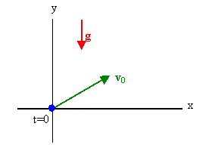
Since we have motion with constant acceleration, the velocity at time t will be v = v₀ + at, and the position will be r = r₀ + v₀t + (1/2)at². Writing this equation in component form and using r₀ = 0, v₀ = v_{0x}i + v_{0y}j, and a = a_{y}j = -gj we have
v = v_{0x}i + v_{0y}j - gtj, r = v_{0x}ti + v_{0y}tj - (1/2)gt²j.
The position vector r and the velocity vector v at time t have only components along the x- and y-axes. By choosing a convenient orientation of our coordinate system we have simplified the mathematics involved in solving a projectile motion problem. We can treat projectile motion as motion in two dimensions with
v_{x} = v_{0x}, x = v_{0x}t,
v_{y}= v_{0y} - gt, y = v_{0y}t - (1/2)gt².
If the initial velocity v₀ makes an angle θ_{o} with the x-axis, then v_{0x} = v₀cos θ_{o} and v_{0y} = v₀sin θ_{o}.
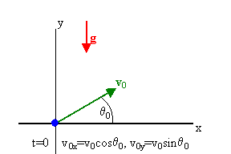
Then
v_{x} = v₀cos θ_{o} = constant, x = v₀cos θ_{o} t,
v_{y} = v₀sin θ_{o} - gt, y = v₀sin θ_{o} t - (1/2)gt².
We can solve x = v₀cos θ_{o}t for t in terms of x, t = x/(v₀cos θ_{o}) and substitute this expression for t into y = v₀sin θ_{o} t - (1/2)gt². We obtain
y = xtan(θ_{o}) - gx²/(2v₀²cos²(θ_{o})),
an equation for the path (or trajectory) of the object. This equation is of the form
y = ax - bx², which is the equation of a parabola which passes through the origin. The trajectory for projectile motion is a parabola.
Example 2.10: A ball is thrown upward and downward from the top edge of a 50-foot-high building. It reaches its highest point 20 feet above and 10 feet out from the building. How far from the building is the ball when it hits the ground?
Solution:

THE HYPERBOLA  When two stones are thrown simultaneously into a pool of still water, ripples move outward in concentric circles. These circles intersect in points which form a curve known as the hyperbola. The intersections of the white circles are points on hyperbolas (in blue) and ellipses (in green). | 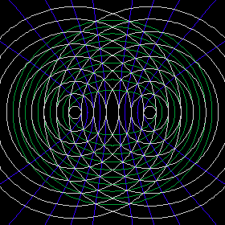
If a right circular cone is intersected by a plane parallel to its axis, part of a hyperbola is formed. Such an intersection can occur in physical situations as simple as sharpening a pencil that has a polygonal cross section or in the patterns formed on a wall by a lamp shade. | 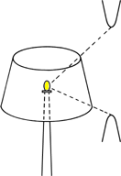
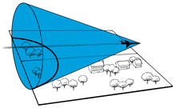 | A sonic boom shock wave has the shape of a cone, and it intersects the ground in part of a hyperbola. It hits every point on this curve at the same time, so that people in different places along the curve on the ground hear it at the same time. Because the airplane is moving forward, the hyperbolic curve moves forward and eventually the boom can be heard by everyone in its path.
Example 2.11: A supersonic jet plane flying at a constant speed produces a shock wave in the shape of a cone. If the plane's path is parallel to the ground, the intersection of the cone with the ground is a hyperbola. Find the equation of the hyperbola if the center is at the origin of a coordinate system, one vertex is at (-42,0), and the hyperbola passes through the point (-126,30$\sqrt{3}$).
Solution:

The Hyperbola has many applications: many telescopes use hyperbolic (hyperbola-shaped) lenses. Hyperbolic gears are used in many machines, and in industry. Sound waves travel in hyperbolic paths, and so there are applications of the hyperbola in navigation.
Example 2.12: Hyperbolic Cooling Towers
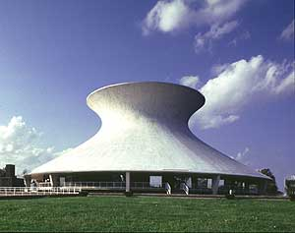
A cross section of a nuclear cooling tower
is a hyperbola with the equation
$$\frac{x^{2}}{{\text{90}}^{2}}−\frac{y^{2}}{{\text{130}}^{2}}=1$$
If the tower is 450 feet tall and the distance
from the top of the tower to the center of the
hyperbola is half the distance from the base of the tower to the center of the hyperbola,
find the diameter of the top and the diameter of the base of the tower.
Solution:

LORAN (LOng RAnge Navigation)
LORAN is a radio navigation system using low frequency radio transmitters that uses multiple transmitters (multilateration) to determine the location and speed of the receiver.

Principle: The navigational method provided by LORAN is based on the principle of the time difference between the receipt of signals from a pair of radio transmitters. A given constant time difference between the signals from the two stations can be represented by a hyperbolic line of position.
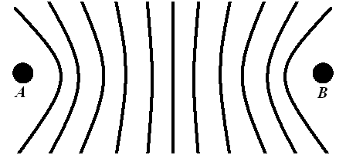
If the positions of the two synchronized stations
are known, then the position of the receiver can be
determined as being somewhere on a particular
hyperbolic curve where the time difference between the received signals is constant. In ideal conditions, this is proportionally equivalent to the difference of the distances from the receiver to each of the two stations.
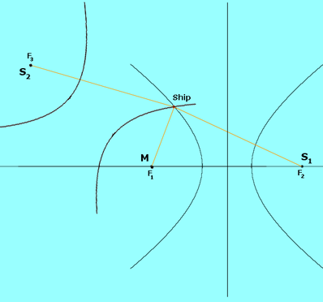
By itself, with only two stations, the 2-dimensional position of the receiver cannot be fixed. A second application of the same principle must be used, based on the time difference of a different pair of stations. In practice, one of the stations in the second pair also may be—and frequently is—in the first pair. By determining the intersection of the two hyperbolic curves identified by the application of this method, a geographic fix can be determined.
In the picture above, M and S₁ are the focal points
of one hyperbola. M and S₂ are the focal points of
the second hyperbola. Where these hyperbolas
meet is the location of the ship.

Example 2.13: Suppose that a radio transmitter B is located 400 miles due east of another radio transmitter A on a coastline. A ship received the signal from B 1200 microseconds before it received the signal from A.
- Assuming that the radio signals travel at a speed of 980 ft/ms, find the equation of the hyperbola on which the ship lies.
- If the ship is due north of B, how far off the coastline is the ship?
Solution:

